Key Idea: Scientists can find of relative age of rock layers based on their order in the earth.

1. Rock Layers
   1. Sedimentary rocks are formed when sediments are cemented together by heat and pressure to form rocks
   2. 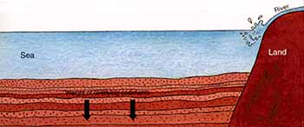This conversion of sediments into rock happens _________________________________________________________

_______________________________________ by new sediments. Sedimentary rocks form in horizontal layers.

* 1. When the sedimentary rock buried deep enough they undergo more heat and pressure to become ___________________________________________________________________________________________________.

*Quick Review: if sedimentary rocks undergo heat and pressure to become a new type of rock, what type of rock is it now?? _____________________________________________________________________________*

* 1. These layers can be used to help scientists to date _________________________ and __________________________.

1. The Law of Superposition
   1. The Law of Superposition states that each undisturbed layer of sedimentary rock is __________________ than a layer _______________________________________ it.
      1. The _____________________________________________________________________________ forms first, which means that it is the oldest
      2. Each layer above that is __________________________________________________________________________ and the top layer is the ________________________________________ of all.
      3. This ordering is a type of ______________________________________________ ____________________________ because you can’t be sure when each layer was formed, so you know the layer’s age in relation to the other layers
   2. Unconformities
      1. An undisturbed rock layer means the horizontal rock layer is intact, it has ___________________

_____________________________________________.

* + 1. When a rock layer is disturbed, it is called an __________________________________________
    2. 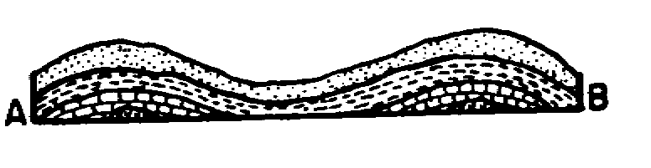There are 4 types of unconformities
       1. _________________________________________
       2. ____________________________________________

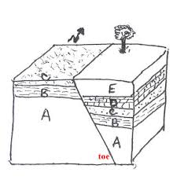

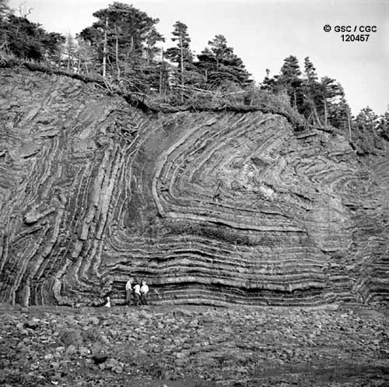

* + - 1. ________________________ (looks like a taco)
      2. _____________________________ _______________________________: here molten rock forces its way up through _________________________________ _____________________________. Because the sedimentary rock have to be present before the molten rock can cut through, the igneous rock must be _______________________________ than the layers it cuts through.
         1. 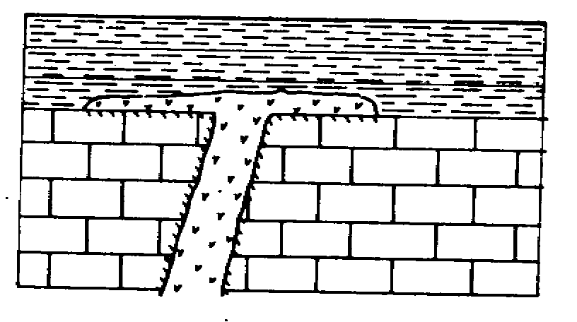The molten rock can erupt and flow to the surface of the earth and form its ___________________ ____________________ of igneous rock on top of the sedimentary rock.
    1. If there is an unconformity, then the _______________________________________________________________

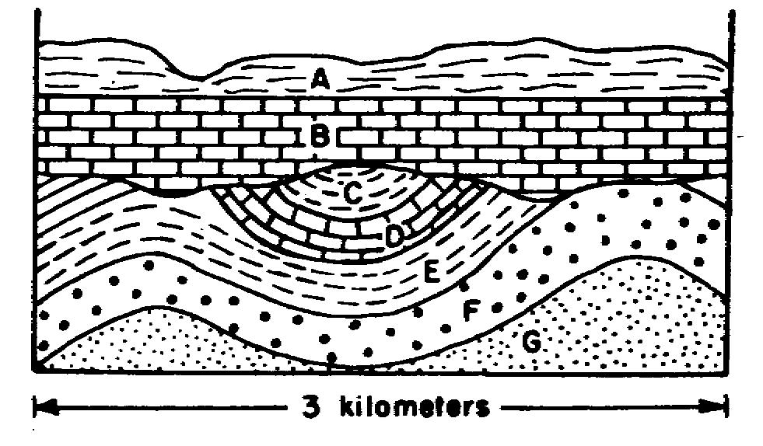______________________________________________. Scientists can determine the original order by comparing the disturbed rock layers with a similar stack of undisturbed rock layers.

**Partner Practice:** Walk around the room with a partner and at each station there will be a rock layer diagram. You have to write the rock layers in the right order.

Station 1: ___________________________________________________________________________________________________________________

Station 2: ___________________________________________________________________________________________________________________

Station 3: ___________________________________________________________________________________________________________________

Station 4: ___________________________________________________________________________________________________________________

Station 5: ___________________________________________________________________________________________________________________

Station 6: ___________________________________________________________________________________________________________________

Station 7: ___________________________________________________________________________________________________________________

Station 8: ___________________________________________________________________________________________________________________

**GEOLOGIC COLUMNS HOMEWORK**

For this project, you will create your own geologic column (like the ones we have been studying and putting in order in class).

* the steps by which your geologic column was formed
* a colored sketch of your geologic column

In your geologic column, you must have **at least two** of the following events occur:

* folding
* faulting
* bend
* an intrusion